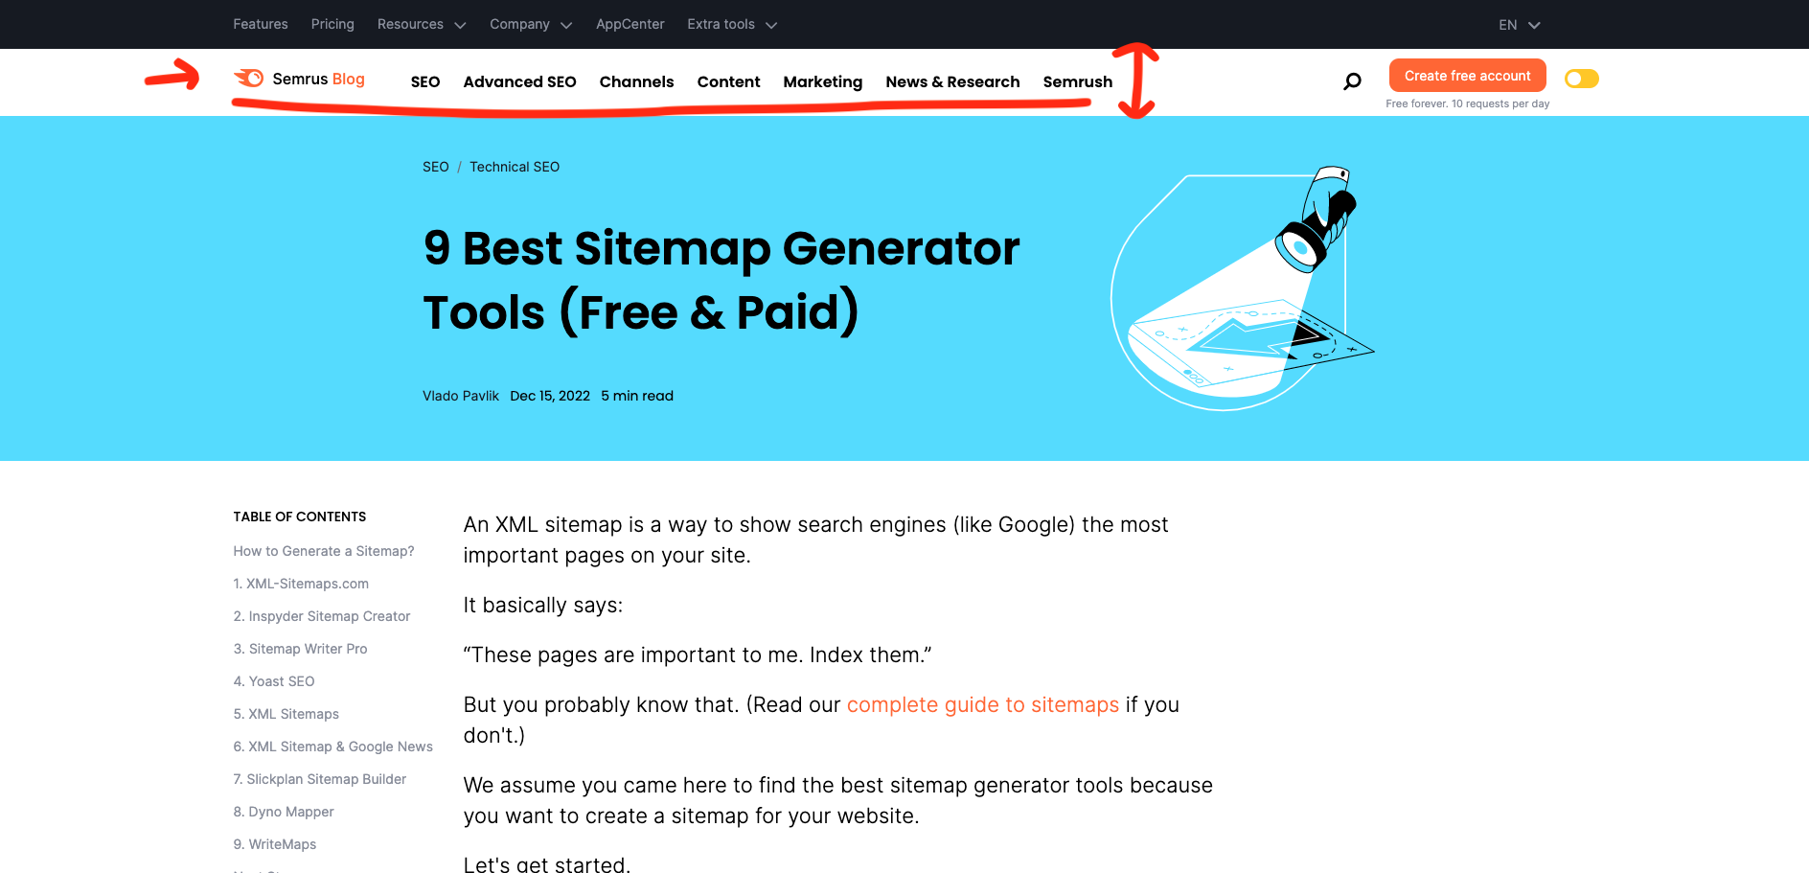

1. Center align vertically properly



1. Left and right margin is not proper while resizing the screens